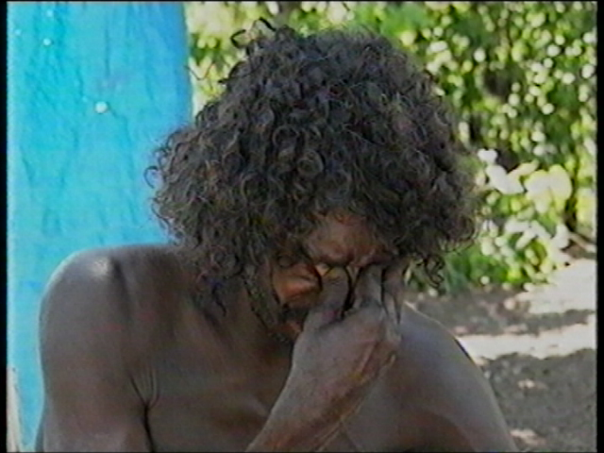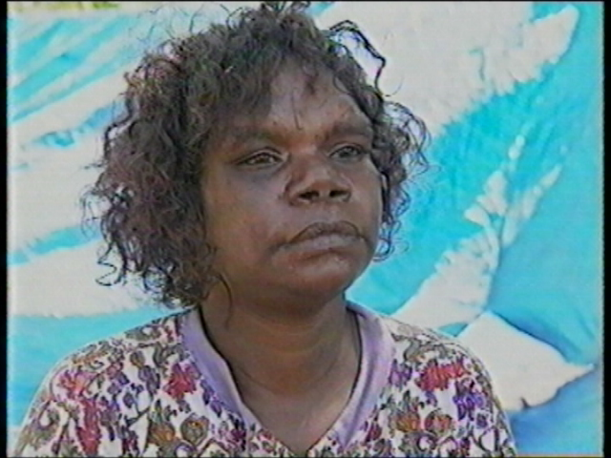

At the camp, Len and Peppi were worried about Bob.

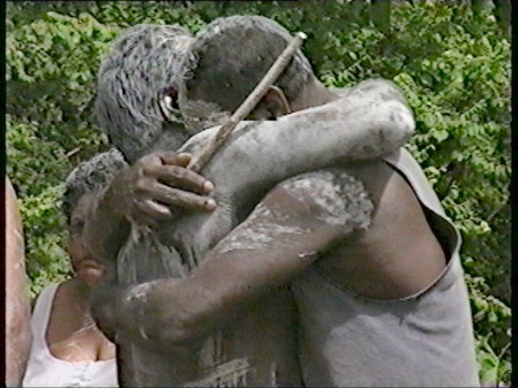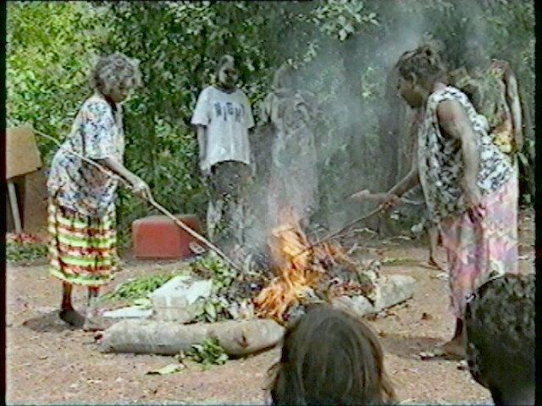

On January 22nd , 1997, Gojok died. The next day, campers from around Darwin came to Lee Point for ceremonies. The same day, Gojok’s things were burnt at his camp.

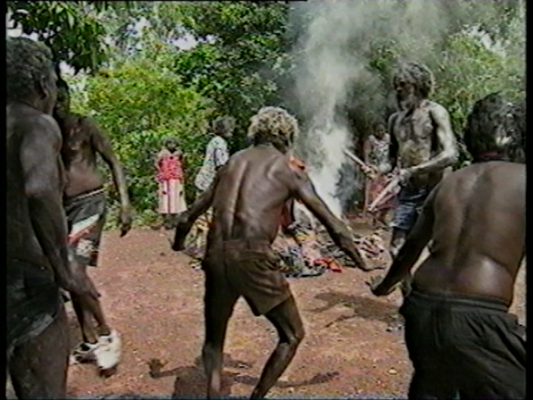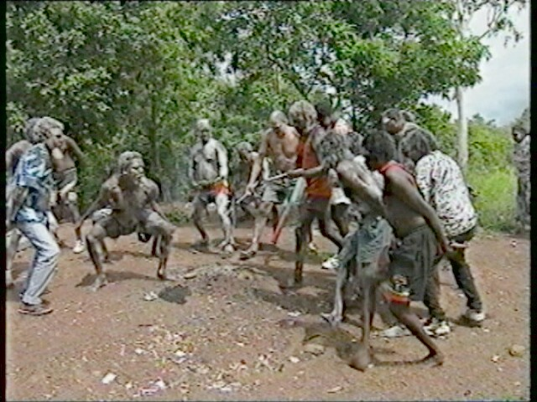

The men did a crocodile dance in honour of Gojok as they buried the ashes of the fire.

